

Visualising World Population

Data Visualisation And analytics

Video link: https://youtu.be/rB74LIFcpD4

Michael Soutar | F20DV | 13/04/2023

# **INTRODUCTION**

In this report you will find the justification and reasoning behind why I chose to select world population and compare the contrasts between the world happiness index as an attempt though it unfortunately didn’t work as planned. Originally, I wanted to select world happiness and compare it to the weather but the data just wasn’t available unlike that of the world population. Searching around I found dataset from Kaggle but choose to use the dataset for the world population, from “Our Would in Data” as it matches what sort of information I wanted to showcase for the world population.

Now the data presented had to be complex in natural, which I had originally overlooked. Hence why there is 3 separate JavaScript files in the code as: Line Chart, Pie Chart and Box Chart as I had started on those 3 before realizing I had to do something a bit more complicated. So I elected to keep the line-chart and the world map but unfortunately the world-map didn’t work as intended and I feel if I gave myself more time I would have figured it out eventually.

## **design choice reasoning**

So as mentioned before I elected to do a line chart and the world map but as mentioned the world map didn’t work as intended so all I was left was the line chart. The line chart is broken into two sections. One as a basic line chart that shows the increase in population over a number of years and the other as a other line chart that when selected, the user can highlight on certain years and the first chart will update accordingly. This means if a user wants to select the years of 1950-1970 the first graph will update showing more concise data. The world map that I had intended to implement was to have it that when the user clicks on the country on the map the line chart would update to whatever country that the user had selected. As mentioned, this didn’t work so the only way a to change which country to view is by going onto the code and altering the code from say “Asia (UN)” as it is currently to say “France” and the graphs will update that way. The graphs can also be reset via the “reset” button that is on the bottom of the page which means that if you’ve gone to far in the years and wish to focus on the years 1990-2000 then the button can be pressed, and the user can easily move the slider back along.

## **cODE**

As mentioned, I attempted to create a number of different charts to highlight the data, this includes all the filles associated with the project. Bar-Chart.js, Line-Chart#3.js, Pie-Chart.js, World-Map.js and World-Map#2. Even though Line-Chart.js is the only working file I felt it was necessary to include the other files to show that I have worked on them in terms of their implementation but unfortunately just couldn’t get them working. The Line-Chart that I did manage to get working, I chose to reuse a lot of the same code that I had used for the first coursework as I knew it was working and just needed to change a number of the variables to match up with the new dataset that I had. So the only pieces of code that actually have of any relevance is the Line-Chart.js, index.html and style.css. Before I go further with the design choice the style.css it links to the overall design choice of the dashboard. The wrapper that holds the information for the line chart is there, there is a secondary wrapper there for the world map but as it doesn’t work, it was a bit redundant to keep it there, but I feel that showcasing all work done even if it doesn’t work to it’s intended purpose is better than nothing. Then everything else in the style sheet is self-explanatory as it just links to what has been created in the Line-Chart.js file.

There is another 2 datasets in the data folder which I had intended to use but unfortunately did not have the means to do so. This includes the world happiness index from the year 2015 that I had intended to link into the coursework but did not. And the other is just a other dataset for another world population dataset.

### **LINE-CHART.JS**

The chart displays population data for a selected country over time ranging from the years that are presented in the csv file. The constants at the top of the code define the size and margins of the chart. Then, the code loads a CSV file containing the population data for multiple countries. Next, the code creates two SVG elements: one to hold the main line chart, and one to hold a smaller chart used for selecting a specific range of years. The scales for the x and y axes of both charts are defined. The function MakeLineChart is defined to create the line chart for the selected country. It first filters the CSV data to only include the selected country, then sorts the data by year in descending order. The x and y domains are set based on the data, and the line chart is created using the D3 line generator. Finally, the x and y axes are added to the chart.

### **VIDEO**

In the video you’ll see me demoing the code and going over everything that I had managed to do for the coursework. There is no voiceover as I do not own a microphone to use. So instead, I’m just doing a quick recap here.

The video starts off by showing all the code that I have managed to complete and has myself use the brush tool to select which years I want to highlight over. It goes over parts of the code that I had managed to partly complete as well. In the video as well, I have changed the countries from France to Spain to Asia (UN) to show that the dataset do indeed work. Some background music has been added in order for the video to be enjoyable to watch.

### **APPLICATION REQUIREMENTS**

Here you will find all the requirements met for the coursework that I feel I have achieved.

Your application must use your datasets and meet the following requirements.

A1. The theme (topic) of your dashboard should be clear to a user while presenting an in-depth coherentvisualisation story, using only visualisations or adding strategically positioned text on the dashboard.- COMPLETED

A2. Your application should only require a single HTML page called index.html, that is within the root of the project.You are free to create as many additional CSS and JS files as you feel are necessary to support your application. - COMPLETED

A3. All visualisations should be loaded on the single HTML page. – COMPLETED

A4. Use at least three different visualisation types.- PARTIALLY COMPLETED

A5. Select one section of your dataset(s) and create two visualisation layouts to show two sides to the selectedsection of dataset(s):a. One visualisation should present the topic in a positive facet.b. The other visualisation should present the topic in a negative facet. – PARTIALLY COMPLETED

A6. Appropriate data analytics techniques, as explained in the course materials, must be implemented. - COMPLETED

A7. The unique visualisation you develop must be sufficiently complex, interactive and animated while containingmultiple different graphical outputs. – PARTIALLY COMPLETED

## **FUTURE THOUGHTS AND CONCLUSION**

Previously mentioned a number of my code aspects didn’t work as intended which is a shame because if I had given myself more time to implement them all then I may have been able to get it working. If I had managed to get everything implemented on time, I would have had a dashboard in which there would have been the world map – selecting the country would change the rank it had in the world happiness index and also reflect via the change in population as I feel that the greater the population the harder it is to make everyone happy. This would have been reflected in the graph as countries with a smaller population as easier to make happy unlike that of China which ranked 84th place when having a population of well over 1 billion people.

One thing I found out during this coursework is that since I was storing my work on a private repository, the csv file had to be loaded multiple times as GitHub refreshes the raw file. This caused me many issues which made me elect to have the repository to be public and not as secure as one would want coursework to be.

## **APPENDIX**

Here I will store all the images associated with the code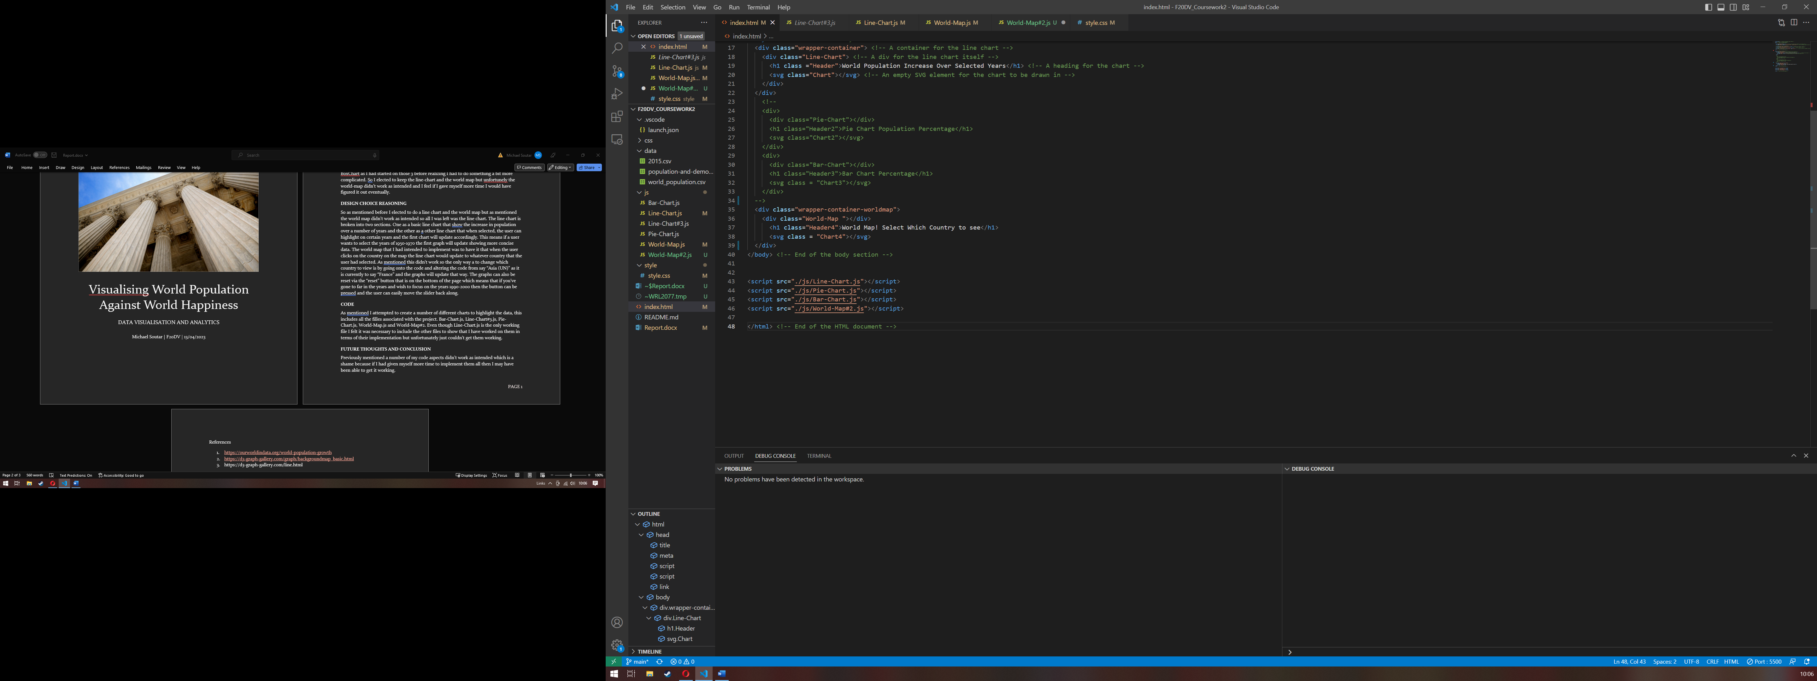

Figure 1: All JavaScript made for project.

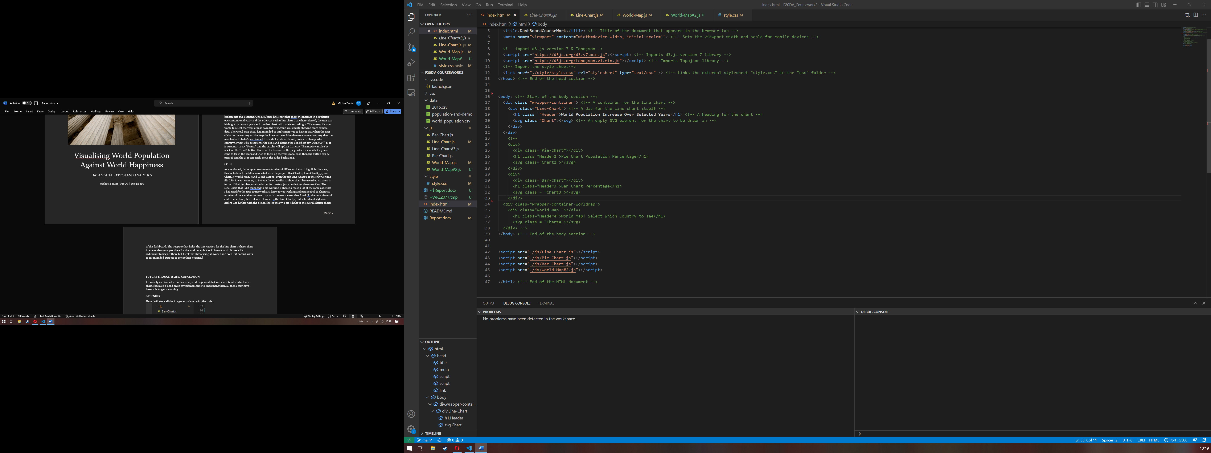

Figure 2: Code made but not used.

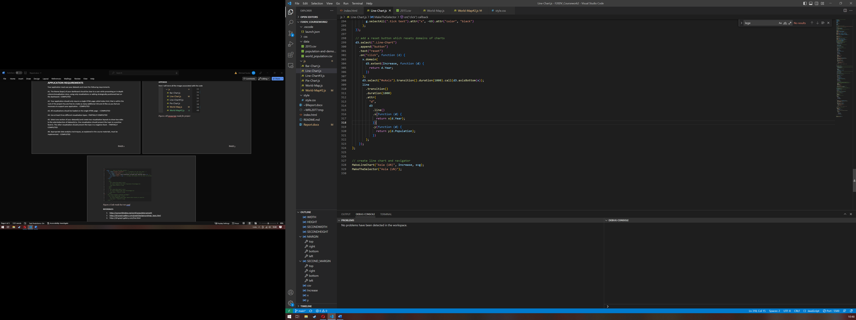

Figure 3: How the reset button was made.

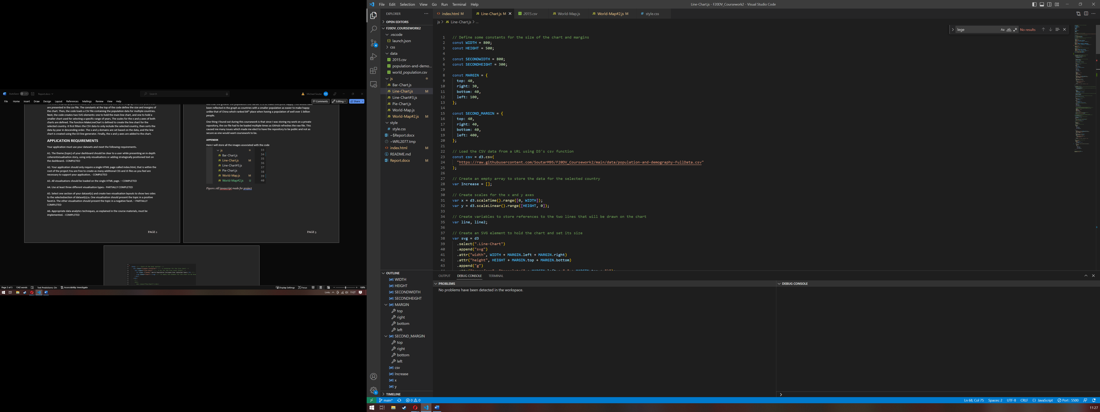

Figure 4: Snippet of code.

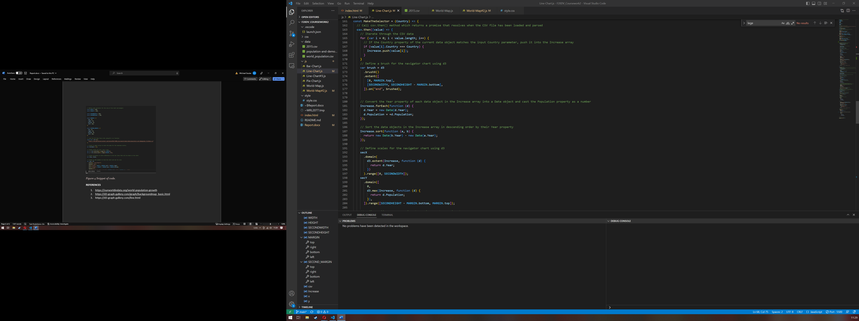

Figure 5: Snippet of code.

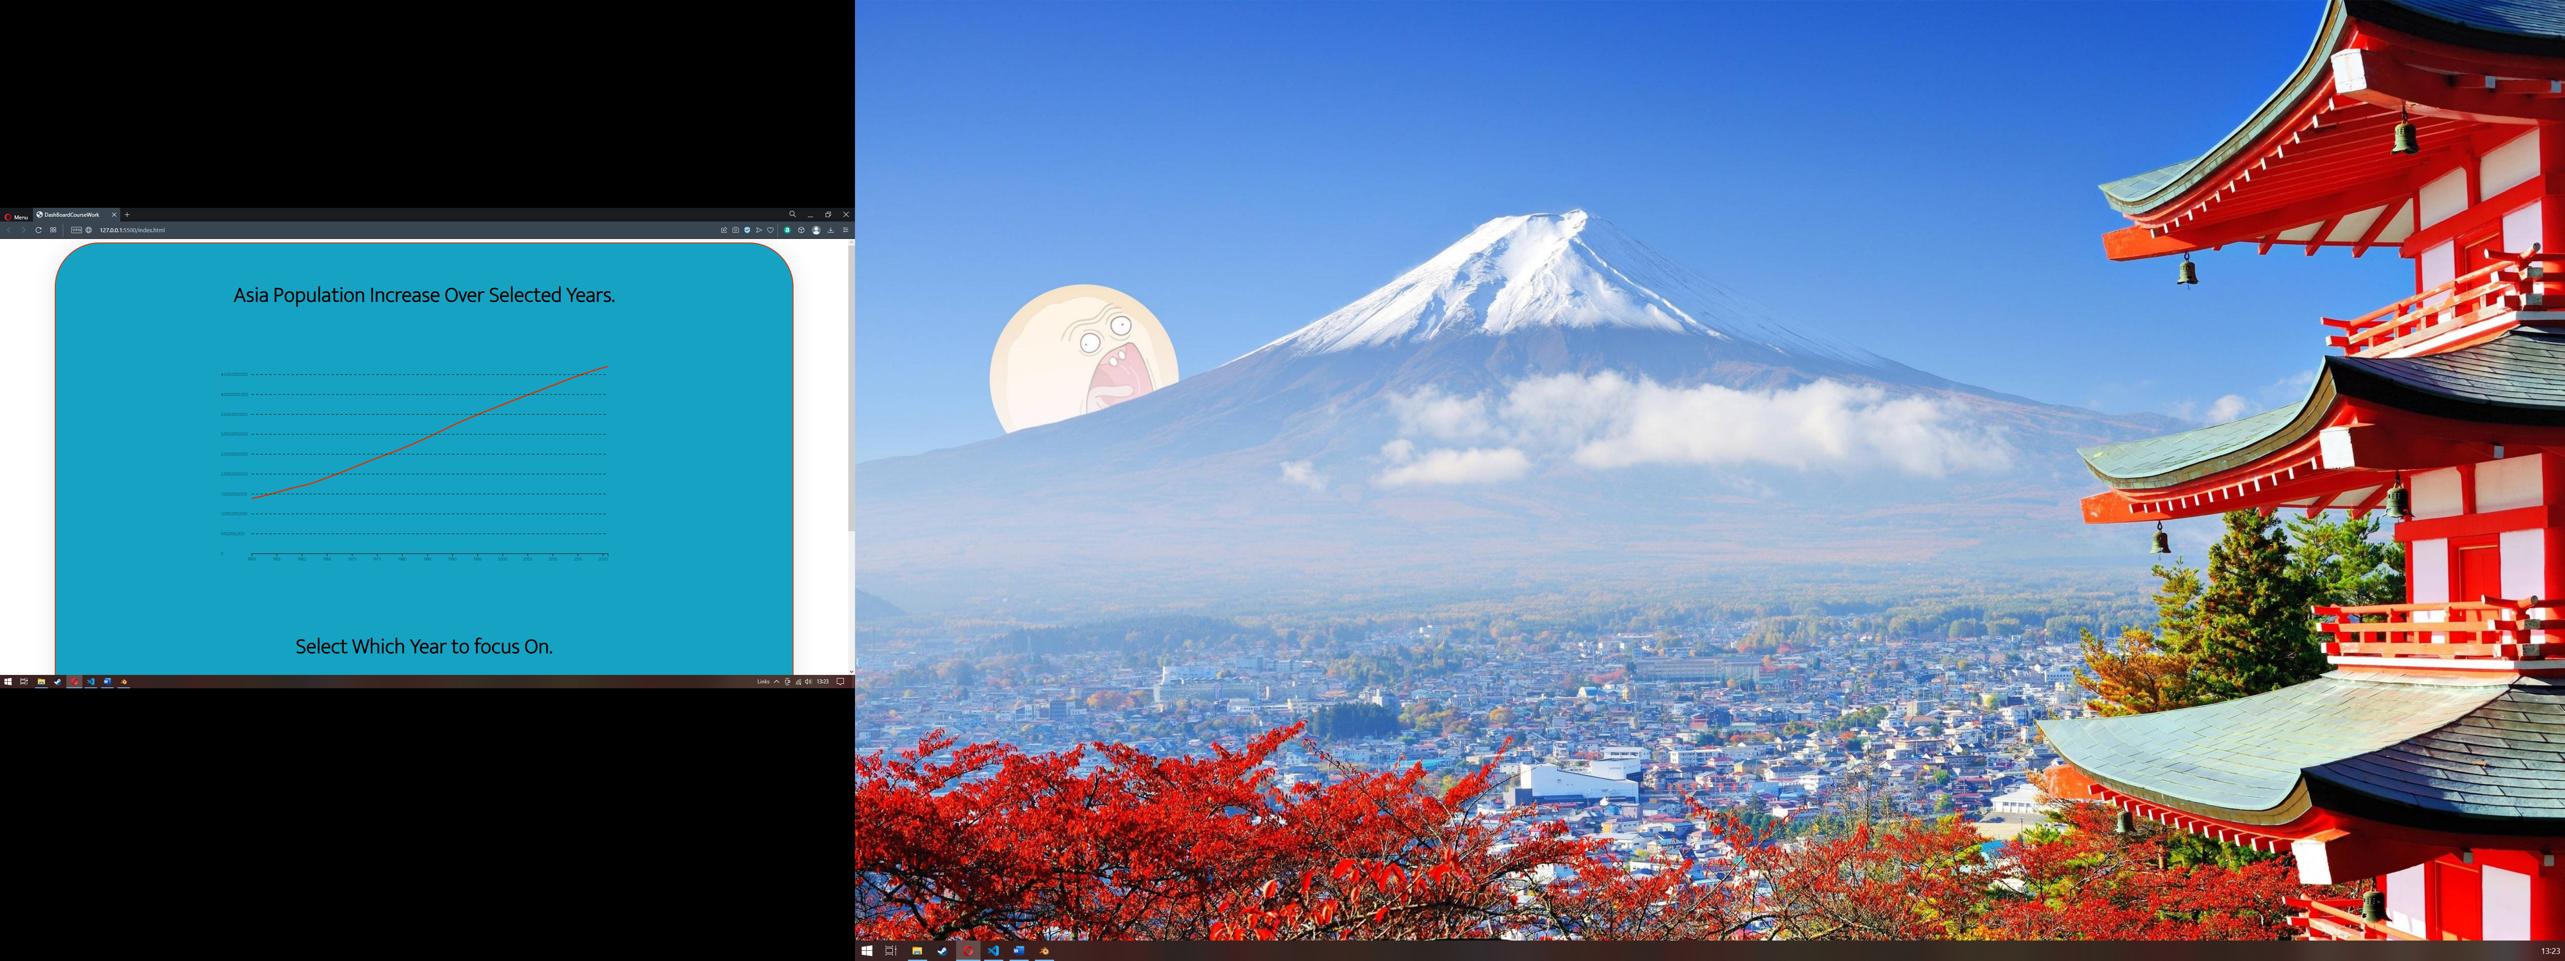

Figure 6: Dashboard Top

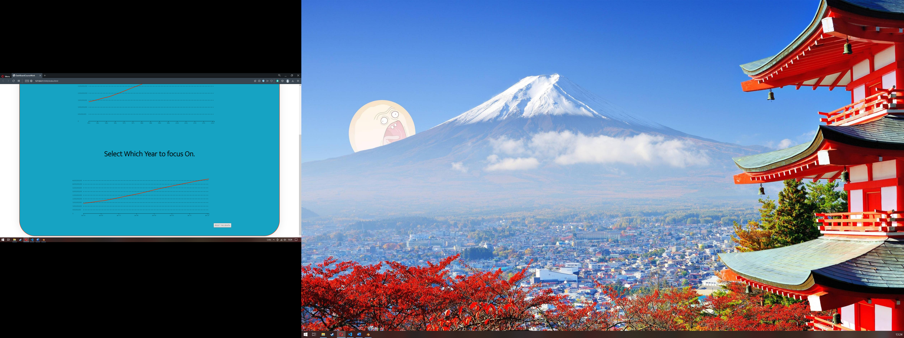

Figure 7: Dashboard Bottom

## **rEFERENCES**

1. <https://ourworldindata.org/world-population-growth>
2. <https://d3-graph-gallery.com/graph/backgroundmap_basic.html>
3. <https://d3-graph-gallery.com/line.html>
4. <https://d3-graph-gallery.com/graph/interactivity_brush.html>
5. <https://gist.github.com/d3noob/bdaf9d5abc467a4895fb115330be35b2>
6. https://stackoverflow.com/questions/71434485/how-to-update-d3-multiline-chart-with-data-change